Membership Form

■ Customer Information

Membership NO.
Name
Date of birth
Phone number
E-mail
Address
Company name
Participation date

■ Benefits

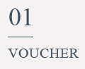 | Benefit 1  - 10 room vouchers at 70% discounted price on normal weekday room rate  Benefit 2  - 2 complimentary breakfast
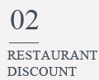 | Benefit 1  - 20% discount on breakfast at all times
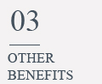 | Benefit 1  - 1 complimentary wine service  Benefit 2  - 1 travel bag gift  Benefit 3  - 1 set of premium amenity gift
* 2 extra complimentary breakfast are given for renewed members

■ Bank Account Information

Bank name | Korea Post Bank
Account number | 601526-01-000597
Account holder | Haeundae Libero Hotel Nara Trade (해운대 리베로 호텔 나라교역)
Amount | 150,000 KRW
* Please deposit under your name, and for the confirmation please contact us via e-mail or phone after deposit.

